How to use NODI (no data indicator) Codes in NetDMR
NetDMR allows you to use codes when you don’t have a data to report. There are 3 ways to use these codes:
- For the entire DMR, in cases where there is no data available for any parameters.
Choose the code from the drop down menu next to Form NODI in the header section of the DMR.
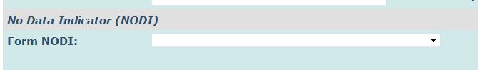
- For a parameter when there is no data to report for that particular parameter. For example, pH was not measured but all other parameters were.
Choose the correct code from the drop down menu located under the parameter name
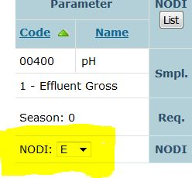
- For a particular parameter limit, when there is partial data available. For example, loading cannot be calculated for the month, but there is data for the concentration
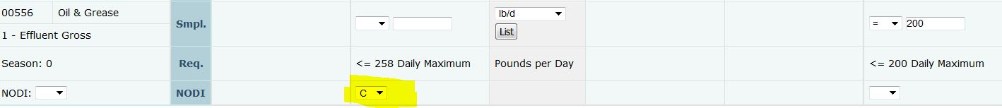

TO SEE A COMPLETE LIST OF ALL AVAILABLE CODES, click on LIST on your DMR column headings

